COMPUTER NETWORKS LAB-3

NAME: LIKHITH R

SECTION: K

SRN: PES1UG20CS659

ROLL NO: 12

**Server Side:**

Step 2: Check your Web Server At the end of the installation process, Ubuntu 16.04 starts Apache.

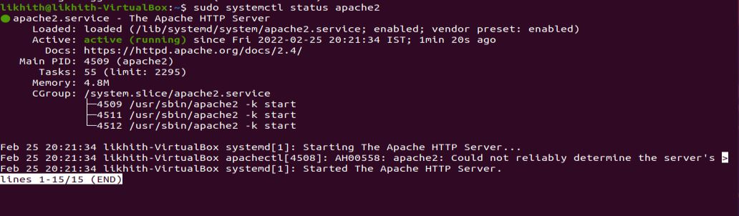

Step 3: Server IP address can be set by the following command:

$sudo ip addr add 172.16.10.1/24 dev enp0s3

$sudo ip addr

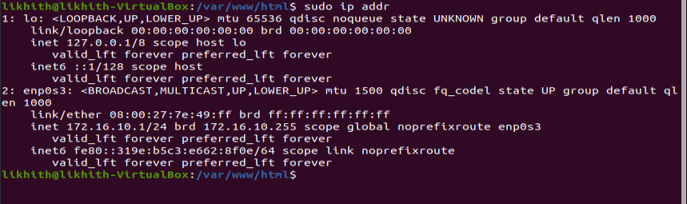

Step 4: The apache2.conf file present in the etc/apache2 directory is modified as:

a) The keep-alive option was set (i.e. value was made ON)

b) The MaximumKeepAliveRequests were set to 2

$sudo nano /etc/apache2/apache2.conf

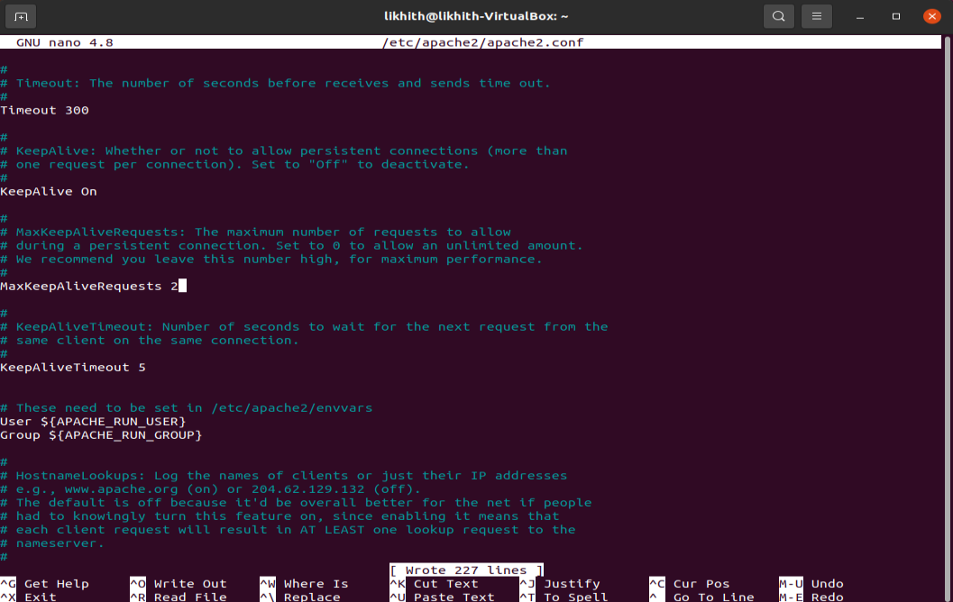

Step 5: Store images in the server path. A html page consisting of 10 images having size > 2MB

were placed and accessed by the client.

This html page is stored in the location - /var/www/html/file_name.html.

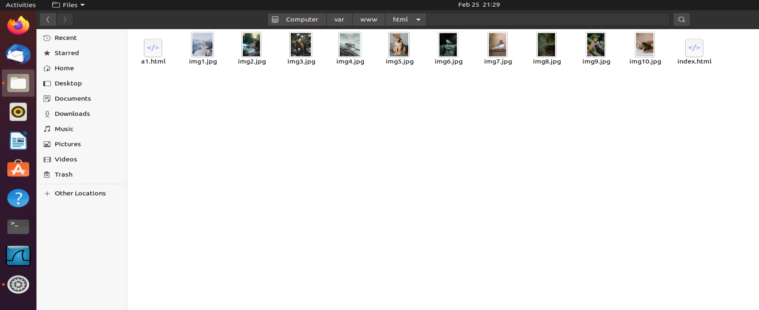

Step 6: Prepare a web page as shown below. The html file needs to add 10 images.

(Kindly skip the style attribute in the below image)

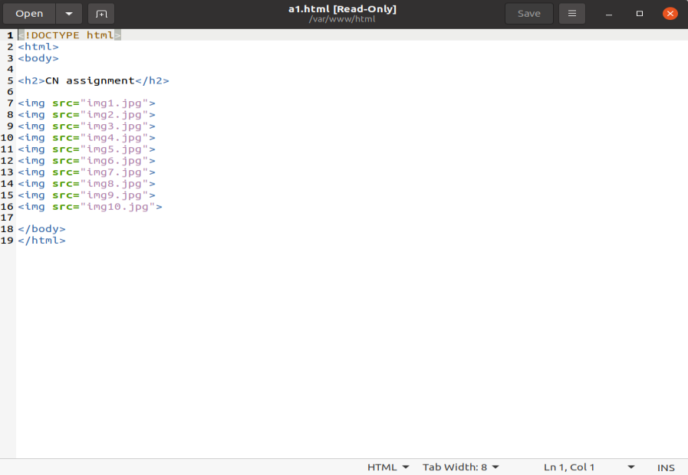

**CLIENT SIDE:**

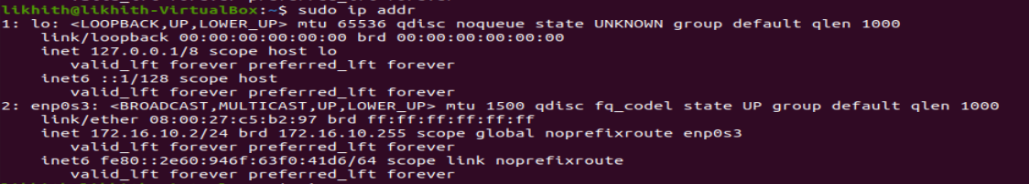

**NON-PERSISTENT:**

Non-Persistent-connection-per-server : 0

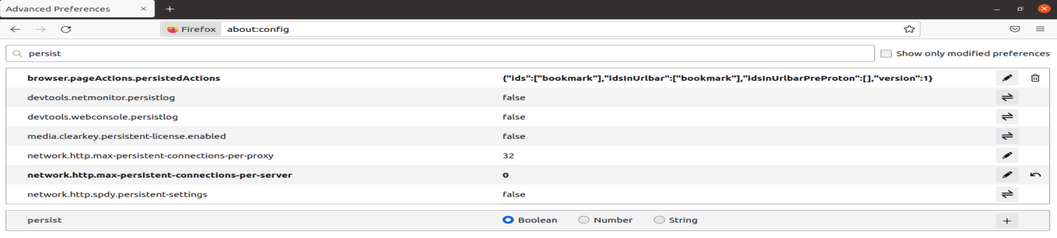

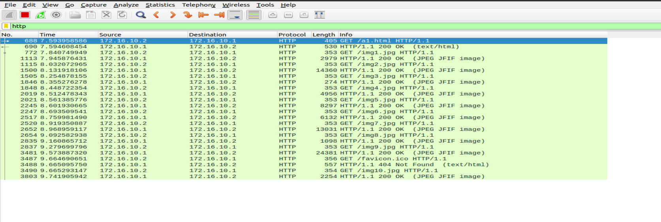

Time: 9.741905942-7.593958586 = 2.147947356

PERSISTENT:

Persistent-connection-per-server : 2

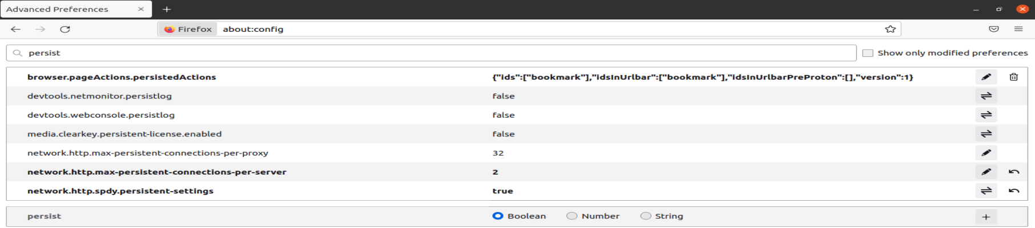

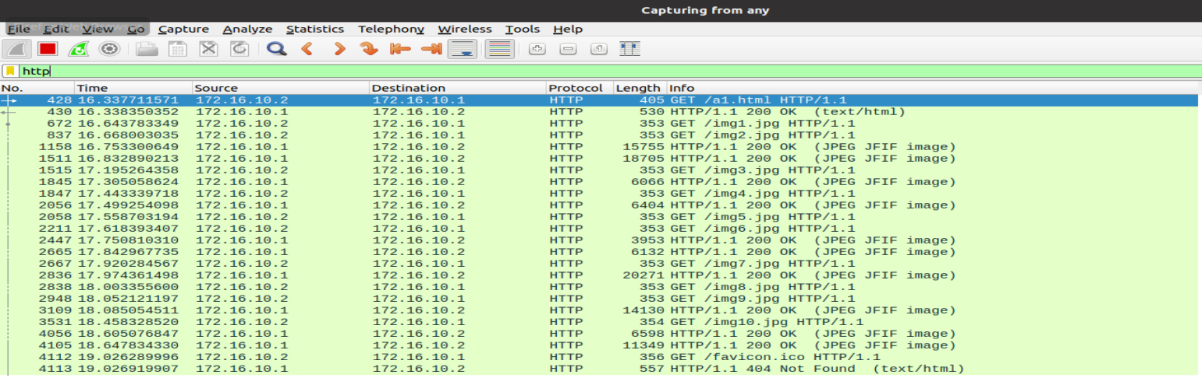

Time: 18.647834330-16.337711571 = 2.310122759

Persistent-connection-per-server : 4

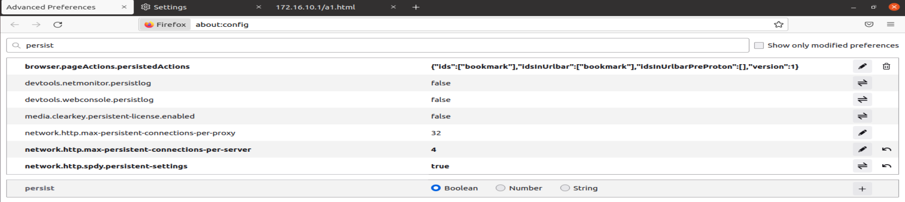

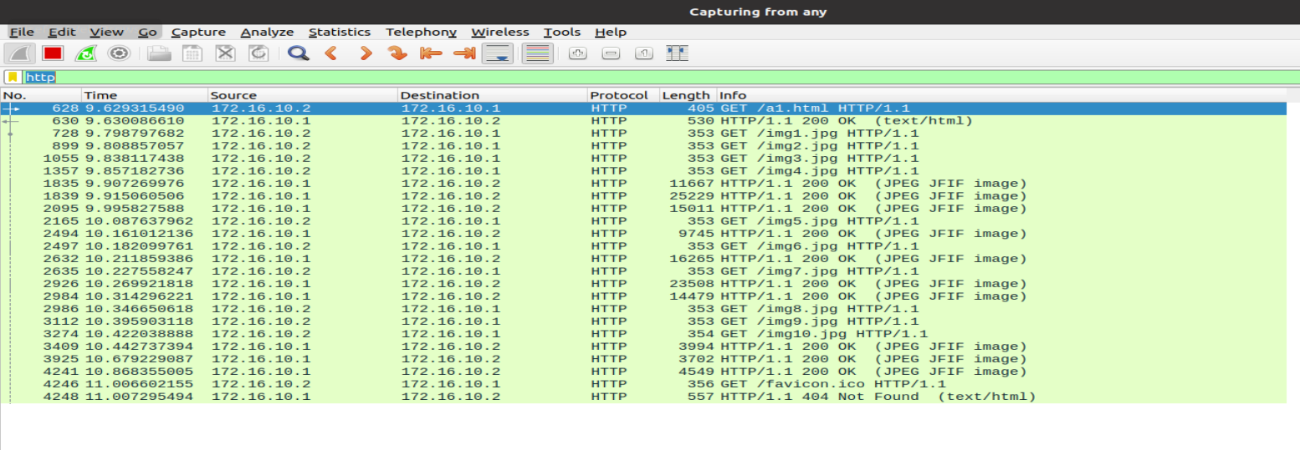

Time: 10.868355005-9.629315490 = 1.239039515

Persistent-connection-per-server : 6

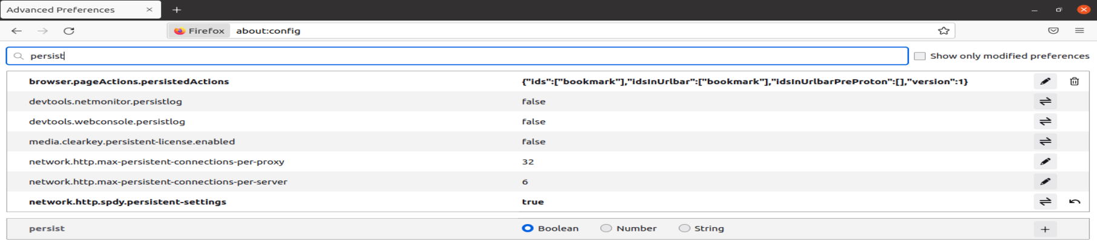

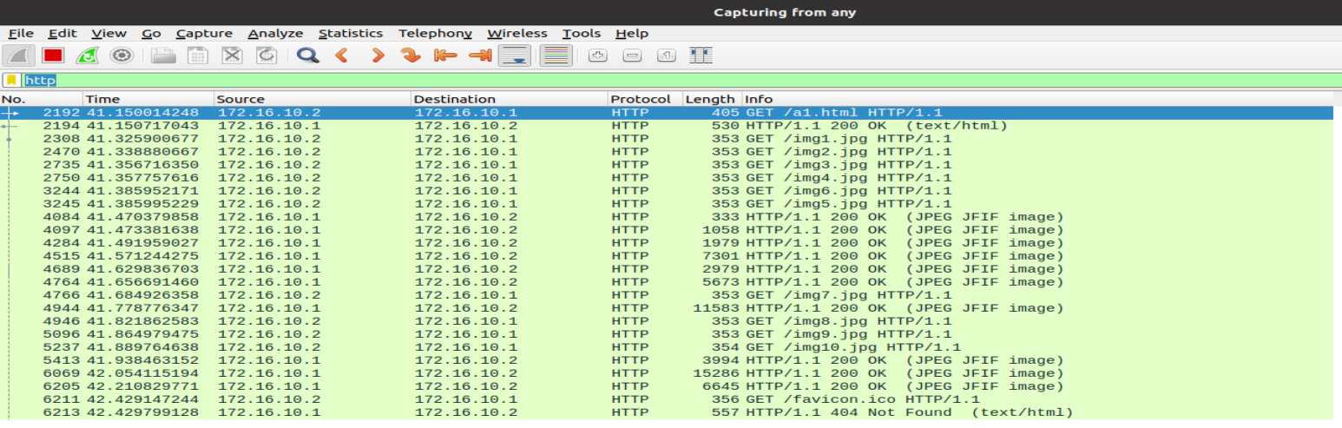

Time: 42.210829771-41.150014248 = 1.060815528

Persistent-connection-per-server : 10

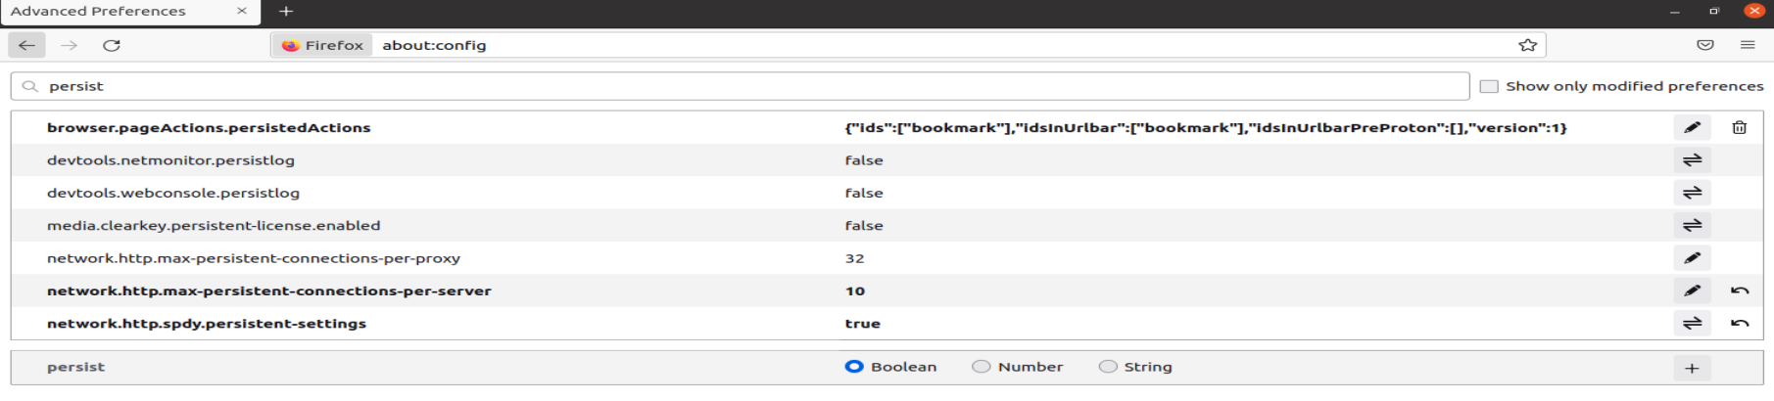

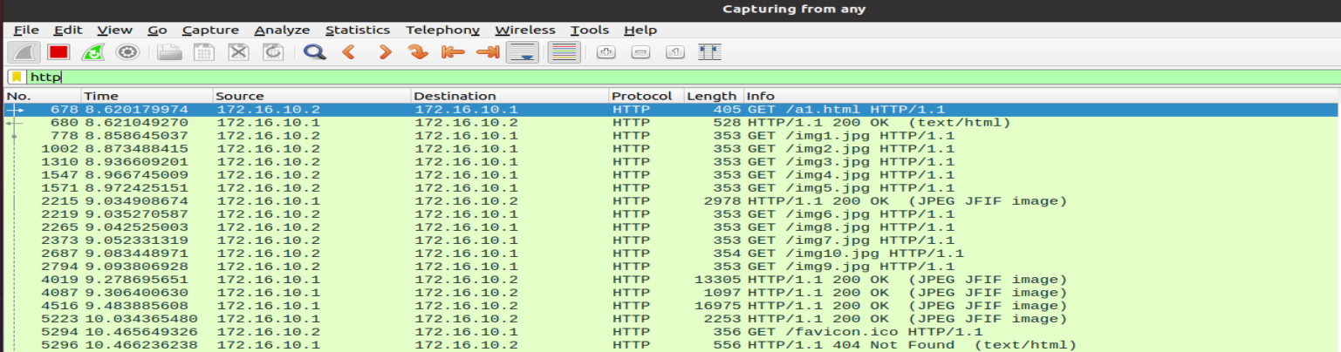

Time: 10.034365480-8.620179974 = 1.41485506

**Conclusion:**

The optimal number of HTTP persistent connections are 6.

The time difference for 6 connections is found to be the least

***3(a) - UNDERSTANDING WORKING OF HTTP HEADERS***

1. To install apache utility



1. Provide username and password to set authentication





1. To setup the authentication phase

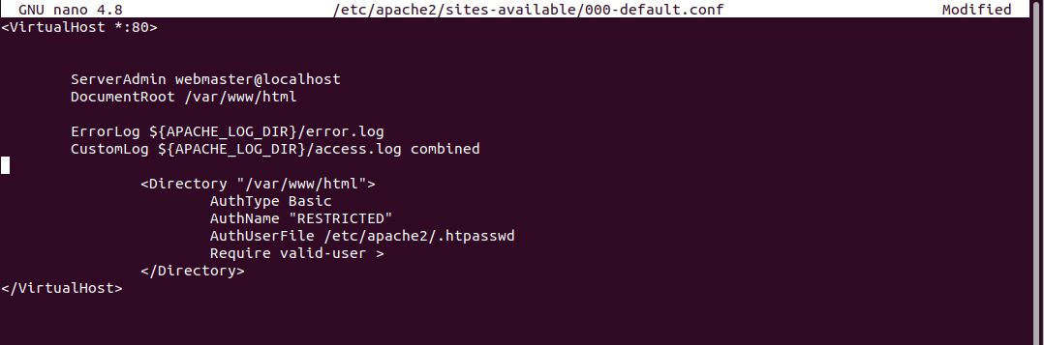

1. Localhost access

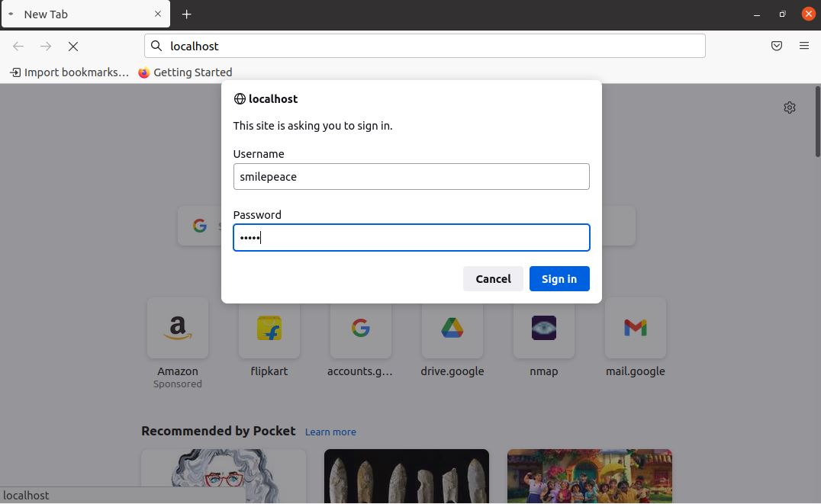

1. Wireshark is used to capture

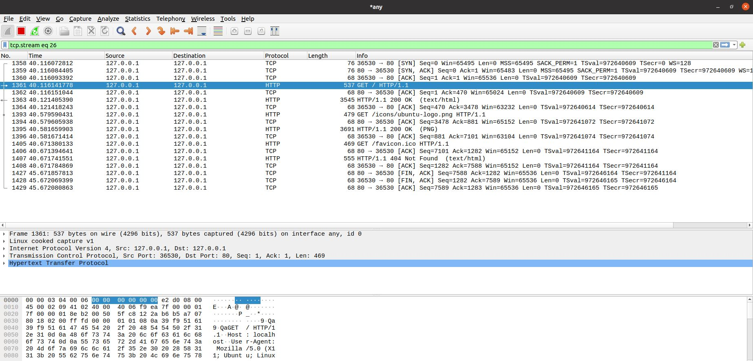

1. The password retrive

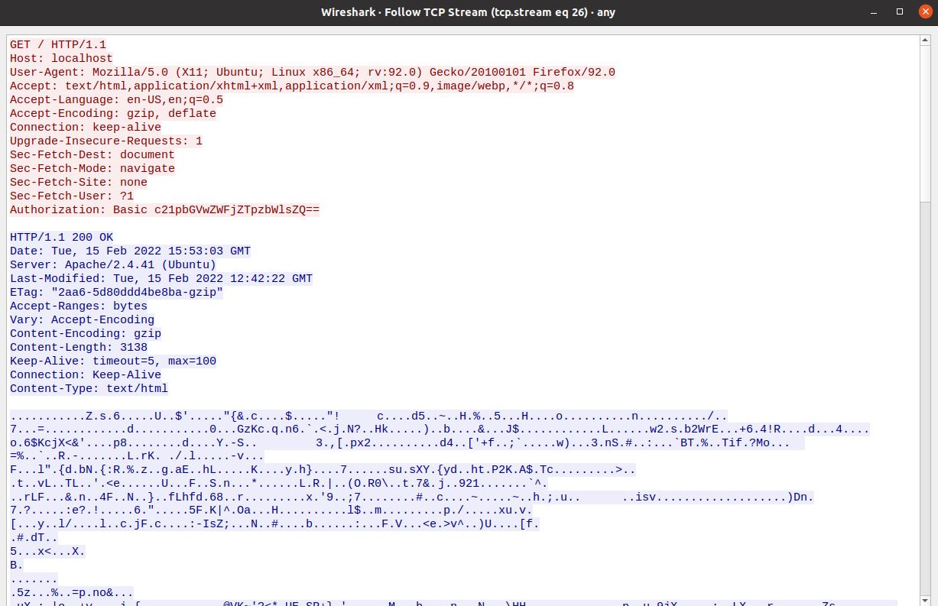

**2) COOKIE SETTING**

a. Code to set the cookie

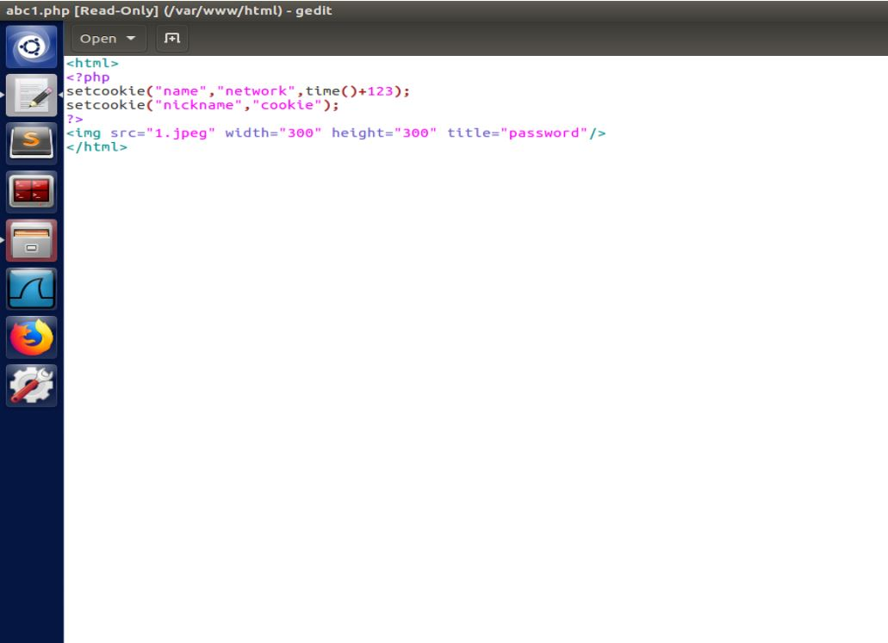

b. The .php file is placed under /var/www/html for accessing

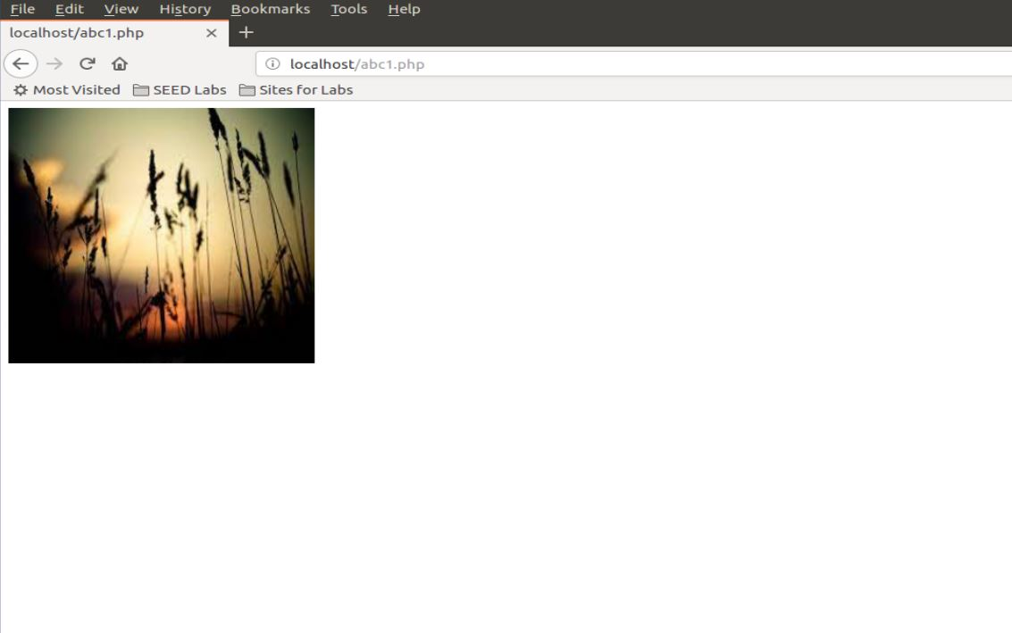

c. The packets are captured using wireshark

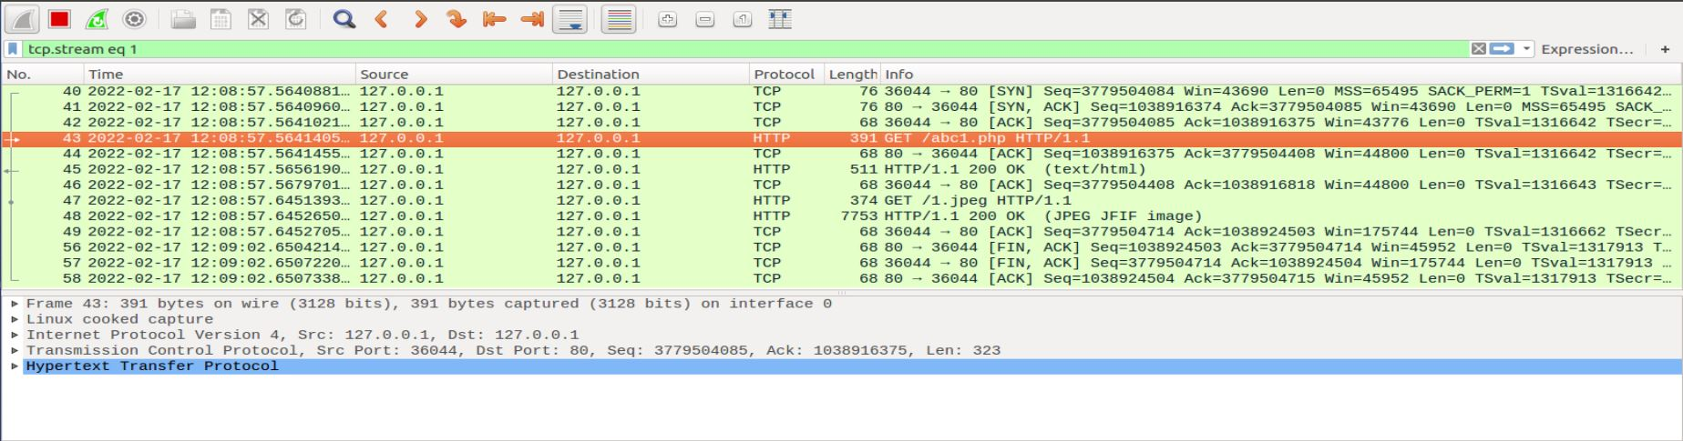

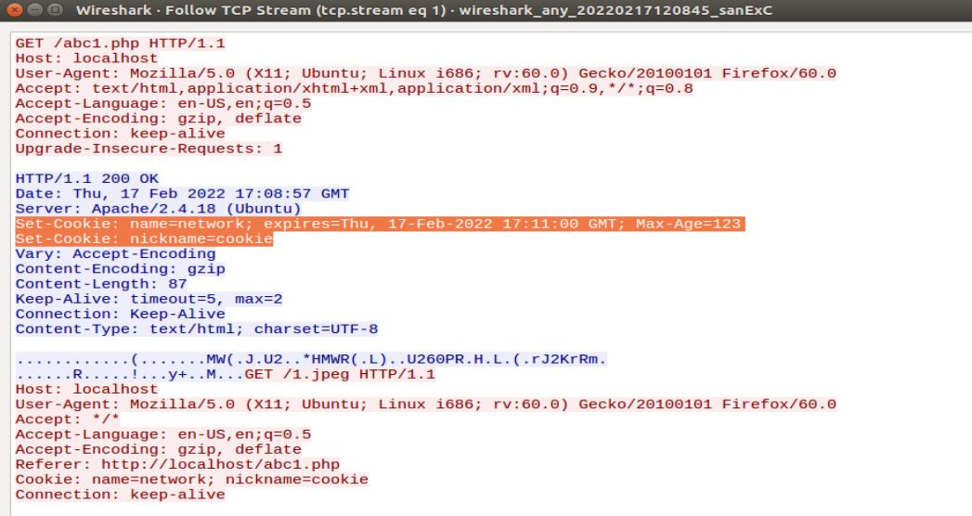

The Cookie is set.

**3) Conditional Get :**

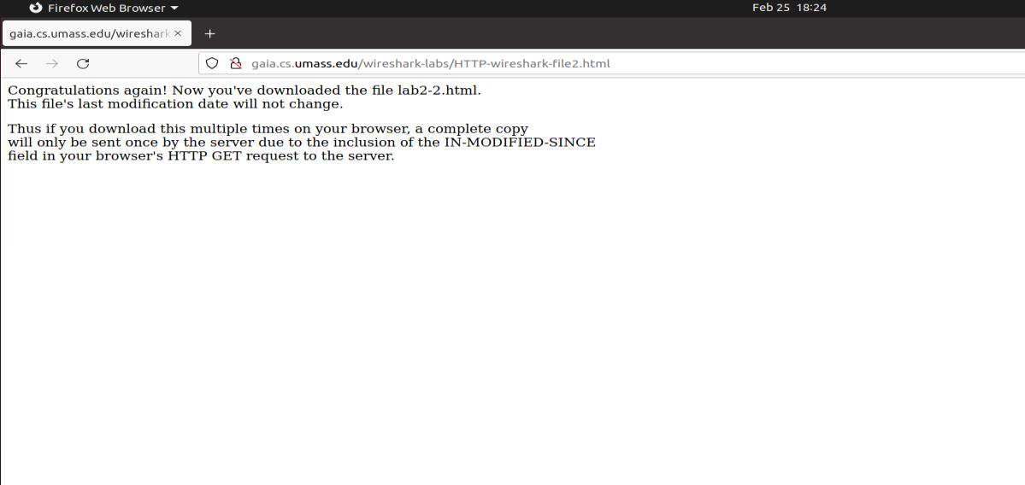

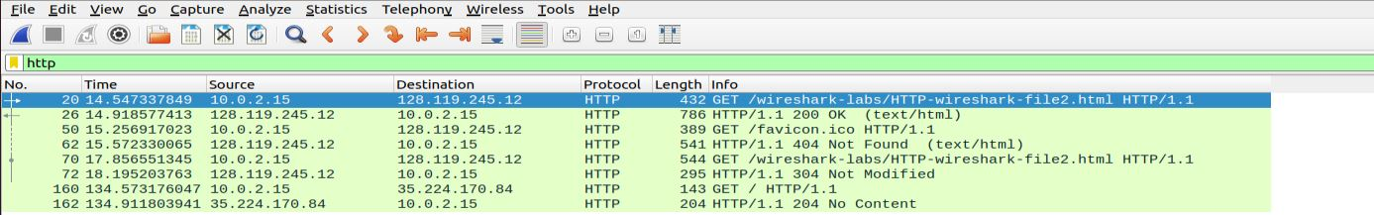

**First HTTP request:**

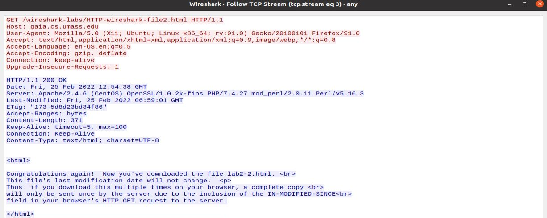

NO, there is no “IF-MODIFIED-SINCE” line in the get message.

**First HTTP response**

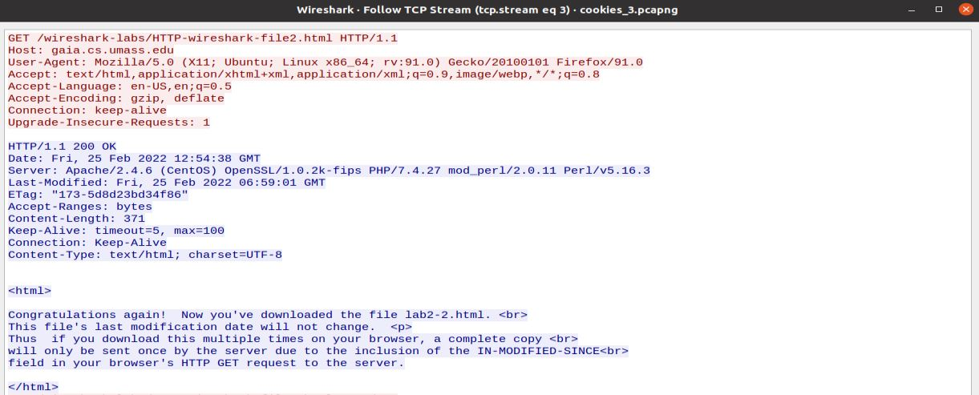

YES, server explicitily return the contents of the file.

The server sent the data which is showed on the browser.

**Second HTTP request:**

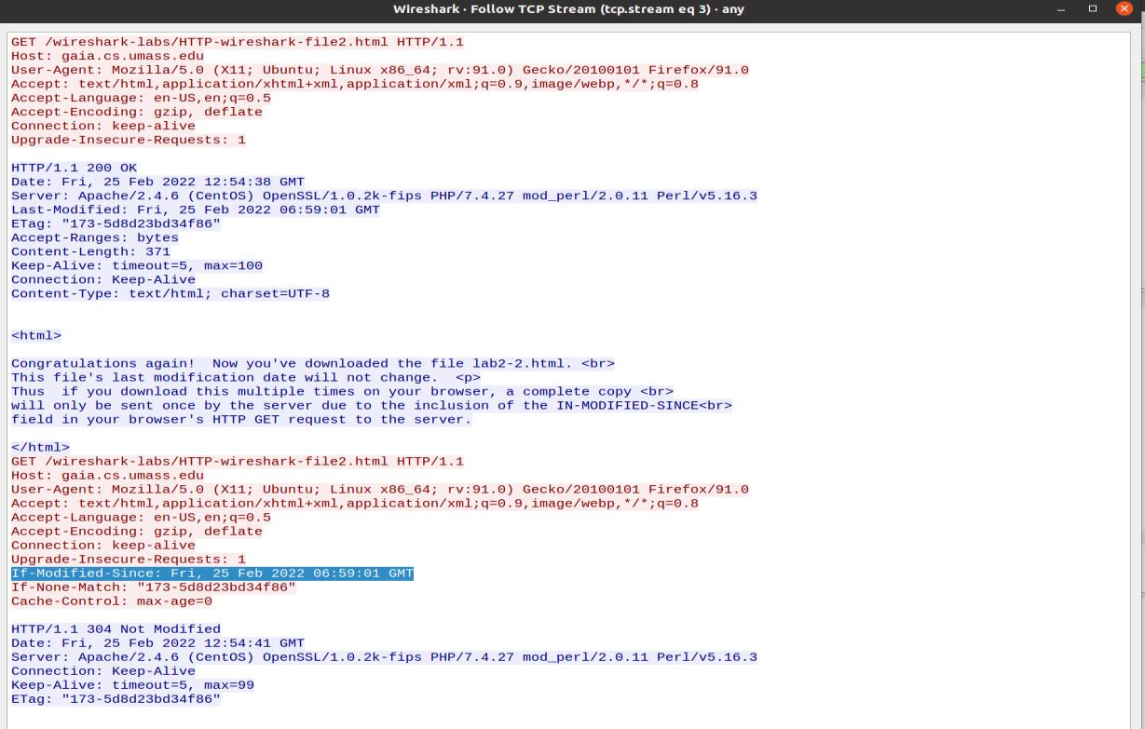

YES, In the second HTTP message “IF-MODIFIED-SINCE” is included.

It gives the information of the date and time that I last accessed it**.**

**Second HTTP response**

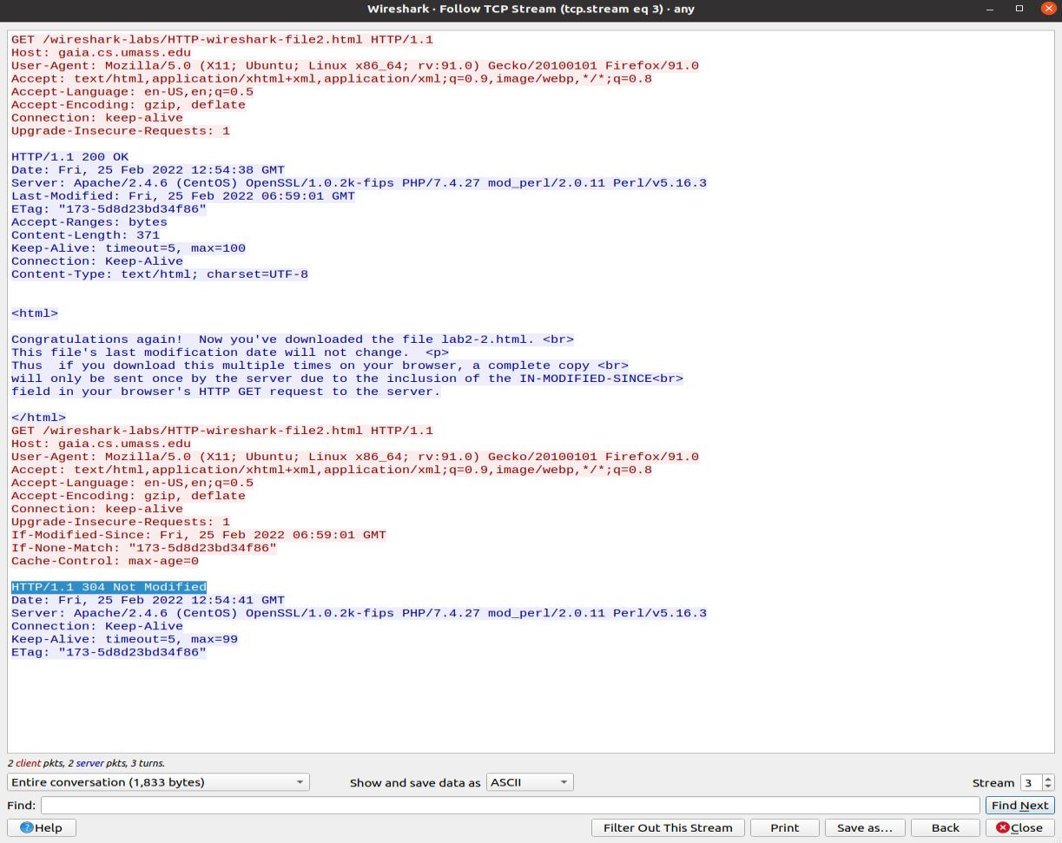

**HTTP status code :** 304

**Phrase : “**Not Modified**”**

The server didn’t explicitly return the contents of the file because

the file content were stored in the cache hence retrived from cache.